INTERNSHIP REPORT

By

# ASHA B (19CS014)

Submitted to the

FACULTY OF COMPUTER SCIENCE & ENGINEERING

*In partial fulfillment for the award of the degree*

*Of*

BACHELOR OF ENGINEERING

**SNS COLLEGE OF TECHNOLOGY, COIMBATORE-35**

(An Autonomous Institution)

**DEPARTMENT OF COMPUTER SCIENCE & ENGINEERING**

**AUGUST 2022**

­­­­­­­   **SNS COLLEGE OF TECHNOLOGY**

*(Accredited by NAAC with A+ Grade)*

Sathy Main Road (NH 209), Vazhiyampalayam Pirivu, Saravanampatti (Post), Coimbatore – 641 035.

DEPARTMENT OF COMPUTER SCIENCE & ENGINEERING

|  |  |  |  |
| --- | --- | --- | --- |
| IMPLANT | TRAINING / INTERNSHIP REPORT 2021-2022 | | |
| Name of the Student : | ASHA B | | Register Number : 19CS014 |
| Year & Branch : | Third Year & Computer Science | | and Engineering |
| Name of the Industry : Period of Training : Total No. of Days : | NET TEL SOLUTIONS  06-03-2022 to 24-03-2022  15 Days | | |
|  | | | |
| GUIDE | | SIGNATURE | |
| Faculty Guide from SNSCT with Designation &Department | | Mrs.N.Vijayalakshmi AP/CSE | |
| Company Guide with Affiliation | | Mr.Pravin | |

# ACKNOWLEDGEMENT

­ ­­This internship opportunity I had with in Net Tel Solutions India Pvt ltd was a great chance for learning and professional development. Therefore, I consider myself as a very lucky individual as I was provided with an opportunity to be a part of it. I’m also grateful for having a chance to meet so many wonderful people and professional who led me through this internship period.

I would like to thank **Mr. Pravin** ,Project Manager for training and supporting me throughout this internship period. Although quite short, for me this was a great experience that I can learn from. It helped me to explore my skills and increased my interest, in **Web Designing.**

I express my deepest thanks to **Mrs.Vijayalakshmi N**, Assistant Professor of CSE department in SNS College of Technology for taking part in useful decision and giving necessary advices and guidance and arranged all facilities to make life easier.

## CERTIFICATE:

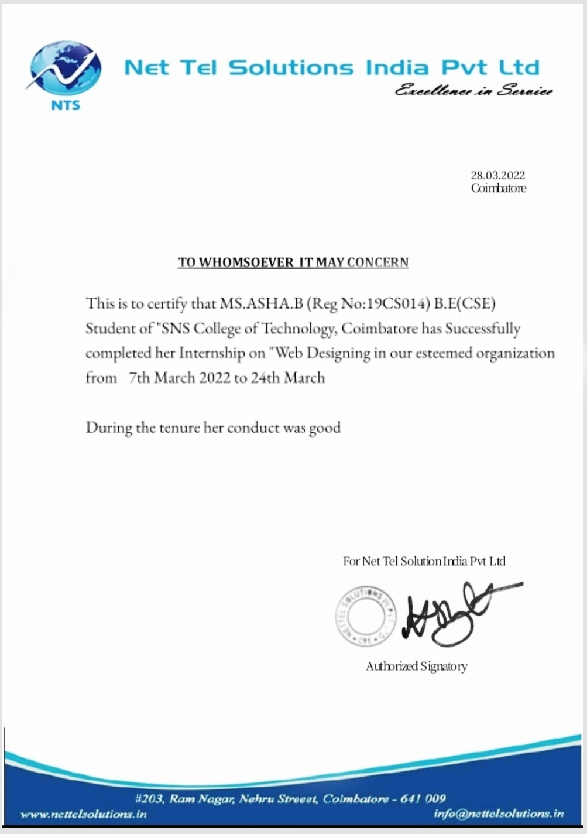

**TABLE OF CONTENTS**

ACKNOWLEDGEMENT 03

CERTIFICATE 04

INTRODUCTION 06

BACKGROUND AND ACTIVITIES OF NET TEL SOLUTIONS 06

NE TEL SOLUTIONS VISION AND VALUES 07

SCOPE AND OBJECTIVE OF STUDY. 08

OBJECTIVE OF THE TRAINING. 16

CONCLUSION. ……...….16

INTERNSHIP TRAINING PROGRESS REPORT 17

COMPANY PROFILE 19

REFERENCE 20

­

## INTRODUCTION:

I carried out my internship at **NET TEL SOLUTIONS INDIA PIATE LIMITED** Mr. Pravin is my trainer and we carried the internship on **“WEB DESIGNING”** at the Web Development in values division. An Internship is a period of work experience offered by an organization for a limited period of time. The purpose of the program is to fulfill the core equipment for the award of a Bachelor of Engineering in Computer science to get a practical aspect to gain experience in different tasks. In conclusion, this was a great opportunity to develop and enhance skills and competencies in my career field which I actually achieved.

## BACKGROUND AND ACTIVITIES OF NET TEL SOLUTIONS:

Net Tel Solutions India Private Limited is a private incorporated on 17th December 2014.It is classified as non-govt company and is registered at registrar of companies, Coimbatore.

They want to spread the motto **"Everything Learning"** to every home that has a child that wants to be a careerist.With its flagship Mentorship Programs, bridges the gap between classes and workplaces. Their training is suitable for everyone, from children to professionals and even housewives. They strive to deliver high-quality education, equipping students for greater professional opportunities. Net Tel Solutions functions as a virtual pool, creating channels via which students may maximise their learning capacity.

It gives students access to interactive, collaborative programs that are supervised by industry professionals. It makes it easy to locate Mentorship and Job Opportunities.They have worked with IT titans to develop a dynamic learning environment. They offer a comprehensive learning platform that can be accessed from any location and by any person.

## NET TEL SOLUTION’S VISION AND VALUES:

**VISION:**

* We aim to deliver our mantra “Everything Learning” to every household that is brewing an aspiring careerist. At Net Tel Solutions, we bridge the gap between classrooms and workplaces with our flagship Mentorship Programs.
* We give cost effective software programming and development services, website designing and development and Internet marketing services.
* Our main idea is to give the paramount services with the excellent and latest technologies.
* We follow the approach of bringing a difference to your working by including the customized solutions for your website.
* Mobile Application Development in cutting your development and maintain costs with cross-platform apps that work seamlessly on IOS, Android, and more.
* Corporate Training services provide a comprehensive portfolio of training solutions to help your business achieve and sustain a competitive edge. Our one and two-day workshops provide intensive support for your team, instantly upgrading their skill sets

## VALUES:

* Trust
* Appreciation
* Professionalism
* Honesty
* Responsibility

­­

## SCOPE AND OBJECTIVES OF STUDY:

* To learn about the activities performing through Web designing in the Web Development team.
* Providing quality content on your website, regularly adding new information, establishing trust, marketing your site on other websites and social media.
* The scope of web development is **finding new meanings of implementation in various fields**. As a web developer, you will create websites. That is, you will be responsible for behind-the-scenes coding and programming of websites.

## WEB DEVELOPMENT:

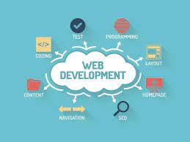 Web development is the work involved in developing a website for the Internet or an intranet. Web development can range from developing a simple single static page of plain text to complex web applications, electronic businesses, and social network services.Web development refers to building website and deploying on the web. Web development requires use of scripting languages both at the server end as well as at client end.

## WEB DESIGNING:

* Web design refers to the design of websites that are displayed on the internet. It usually refers to the user experience aspects of website development rather than software development. Web design used to be focused on designing websites for desktop browsers.
* A web designer works on the appearance, layout, and, in some cases, content of a website.
* Appearance, for instance, relates to the colors, font, and images used. Layout refers to how information is structured and categorized. A good web design is easy to use, aesthetically pleasing, and suits the user group and brand of the website. Many webpages are designed with a focus on simplicity, so that no extraneous information and functionality that might distract or confuse users appears.



* Web design is the process of planning, conceptualizing, and arranging content online. Today, designing a website goes beyond aesthetics to include the website’s overall functionality. Web design also includes web apps, mobile apps, and user interface design.

## TYPES OF WEB DESIGNING:

## 

## STATIC WEBSITE DESIGN

When you simply need a couple of pages on your site and don’t need the data to change, a static design is the best. The info on a static site continues as before and has no changes occurring in the course of time.Static websites are made in HTML,CSS and Java.They are simple to create and are easily crawled by search engines.

## CMS OR DYNAMIC WEBSITE

A Dynamic website can convey dynamic data.This implies relying upon changes occurring ; this site data are updated automatically depending on a couple of criteria.Its design is created on content management platform or CMS like wordpress,joomla and so on.The main hindrance is that this sort of website is hard to design.

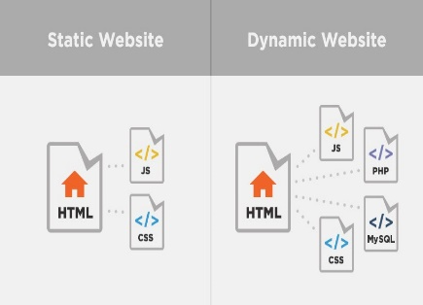

## E-COMMERCE WEBSITE

In the event that you have a store which involves sales,than you need an ecommerce platorm encourage you to deal with all the technical pats of the website.There are a large number of platform encourages you to deal with all the technical parts of the website .There are large number of platforms where you can design an ecommerce site like opencart, woocommerce, zencart, magento, oscommerce etc.,

**HTML:**

* The HyperText Markup Language or HTML is the standard  [mark-up language](https://en.wikipedia.org/wiki/Markup_language) for documents designed to be displayed in a [web browser](https://en.wikipedia.org/wiki/Web_browser). It can be assisted by technologies such as [Cascading Style Sheets](https://en.wikipedia.org/wiki/Cascading_Style_Sheets) (CSS) and [scripting languages](https://en.wikipedia.org/wiki/Scripting_language) such as [JavaScript](https://en.wikipedia.org/wiki/JavaScript).
* [Web browsers](https://en.wikipedia.org/wiki/Web_browser) receive HTML documents from a [web server](https://en.wikipedia.org/wiki/Web_server) or from local storage and [render](https://en.wikipedia.org/wiki/Browser_engine) the documents into multimedia web pages. HTML describes the structure of a [web page](https://en.wikipedia.org/wiki/Web_page) [semantically](https://en.wikipedia.org/wiki/Semantic_Web) and originally included cues for the appearance of the document.
* [HTML elements](https://en.wikipedia.org/wiki/HTML_element) are the building blocks of HTML pages. With HTML constructs, [images](https://en.wikipedia.org/wiki/HTML_element#Images_and_objects) and other objects such as [interactive forms](https://en.wikipedia.org/wiki/Fieldset) may be embedded into the rendered page.
* HTML provides a means to create [structured documents](https://en.wikipedia.org/wiki/Structured_document) by denoting structural [semantics](https://en.wikipedia.org/wiki/Semantics) for text such as headings, paragraphs, lists, [links](https://en.wikipedia.org/wiki/Hyperlink), quotes and other items. HTML elements are delineated by tags, written using [angle brackets](https://en.wikipedia.org/wiki/Bracket#Angle_brackets).
* HTML is a [mark-up language](https://en.wikipedia.org/wiki/Markup_language) that [web browsers](https://en.wikipedia.org/wiki/Web_browser) use to interpret and [compose](https://en.wikipedia.org/wiki/Typesetting) text, images, and other material into visual or audible web pages. Default characteristics for every item of HTML mark-up are defined in the browser, and these characteristics can be altered or enhanced by the web page designer's additional use of [CSS](https://en.wikipedia.org/wiki/Cascading_Style_Sheets).
* HTML can embed programs written in a [scripting language](https://en.wikipedia.org/wiki/Scripting_language) such as [JavaScript](https://en.wikipedia.org/wiki/JavaScript), which affects the behavior and content of web pages. Inclusion of CSS defines the look and layout of content. The [World Wide Web Consortium](https://en.wikipedia.org/wiki/World_Wide_Web_Consortium) , former maintainer of the HTML and current maintainer of the CSS standards, has encouraged the use of CSS over explicit presentational HTML .



## CSS:

* Cascading Style Sheets  is a [style sheet language](https://en.wikipedia.org/wiki/Style_sheet_language) used for describing the [presentation](https://en.wikipedia.org/wiki/Presentation_semantics) of a document written in a [mark-up language](https://en.wikipedia.org/wiki/Markup_language) such as [HTML](https://en.wikipedia.org/wiki/HTML) or [XML](https://en.wikipedia.org/wiki/XML) . CSS is a cornerstone technology of the [World Wide Web](https://en.wikipedia.org/wiki/World_Wide_Web), alongside HTML and [JavaScript](https://en.wikipedia.org/wiki/JavaScript).
* CSS is designed to enable the separation of presentation and content, including [layout](https://en.wikipedia.org/wiki/Page_layout), colours, and [fonts](https://en.wikipedia.org/wiki/Typeface). This separation can improve content [accessibility](https://en.wikipedia.org/wiki/Accessibility); provide more flexibility and control in the specification of presentation characteristics; enable multiple [web pages](https://en.wikipedia.org/wiki/Web_page) to share formatting by specifying the relevant CSS in a separate .css file, which reduces complexity and repetition in the structural content; and enable the .css file to be [cached](https://en.wikipedia.org/wiki/Cache_(computing)) to improve the page load speed between the pages that share the file and its formatting.
* The name cascading comes from the specified priority scheme to determine which style rule applies if more than one rule matches a particular element. This cascading priority scheme is predictable.

## JAVA SCRIPT:

## JavaScript  often abbreviated JS, is a [programming language](https://en.wikipedia.org/wiki/Programming_language) that is one of the core technologies of the [World Wide Web](https://en.wikipedia.org/wiki/World_Wide_Web), alongside [HTML](https://en.wikipedia.org/wiki/HTML) and [CSS](https://en.wikipedia.org/wiki/CSS). JavaScript is a [high-level](https://en.wikipedia.org/wiki/High-level_programming_language), often [just-in-time compiled](https://en.wikipedia.org/wiki/Just-in-time_compilation) language that conforms to the [ECMA Script](https://en.wikipedia.org/wiki/ECMAScript) standard. It has [dynamic typing](https://en.wikipedia.org/wiki/Dynamic_typing), [prototype-based](https://en.wikipedia.org/wiki/Prototype-based_programming) [object-orientation](https://en.wikipedia.org/wiki/Object-oriented_programming), and [first-class functions](https://en.wikipedia.org/wiki/First-class_function). It is [multi-paradigm](https://en.wikipedia.org/wiki/Programming_paradigm), supporting [event-driven](https://en.wikipedia.org/wiki/Event-driven_programming), [functional](https://en.wikipedia.org/wiki/Functional_programming), and [imperative](https://en.wikipedia.org/wiki/Imperative_programming) [programming styles](https://en.wikipedia.org/wiki/Programming_paradigm).

## It has [application programming interfaces](https://en.wikipedia.org/wiki/Application_programming_interface)  for working with text, dates, [regular expressions](https://en.wikipedia.org/wiki/Regular_expression), standard [data structures](https://en.wikipedia.org/wiki/Data_structure), and the [Document Object Model](https://en.wikipedia.org/wiki/Document_Object_Model).



## PHP:

* The term PHP is an acronym for PHP: Hypertext Preprocessor.
* PHP is a server-side scripting language designed specifically for web development.
* It is open-source which means it is free to download and use.
* It is very simple to learn and use.
* The files have the extension “.php”. PHP code is executed in the server.
* It can be integrated with many databases such as Oracle, Microsoft SQL Server, MySQL, PostgreSQL, Sybase, Informix.
* It is powerful to hold a content management system like WordPress and can be used to control user access.



## MY SQL:

* MySQL is released under an open-source license. So you have nothing to pay to use it.
* MySQL is a very powerful program in its own right. It handles a large subset of the functionality of the most expensive and powerful database packages.

MySQL uses a standard form of the well-known SQL data language.

* MySQL works on many operating systems and with many languages including PHP, PERL, C, C++, JAVA, etc.
* MySQL works very quickly and works well even with large data sets.
* MySQL is very friendly to PHP, the most appreciated language for web development.
* MySQL supports large databases, up to 50 million rows or more in a table. The default file size limit for a table is 4GB, but you can increase this (if your operating system can handle it) to a theoretical limit of 8 million terabytes (TB).

## JQUERY:

* jQuery is a small and lightweight JavaScript library.
* jQuery is cross-platform.
* jQuery means "write less do more"

**OBJECTIVES OF THE TRAINING:**

* Connecting what you have learned (theoretical and practical knowledge on your subject field) with actual work experience, in order to complement your field specific skills and learn new ones.
* Apply and analyze at least one future skills.
* There can be one or two aims, but both development of field specific skills as well as future skills have to be represented.

## CONCLUSION:

This internship has been a very useful experience for me. I even learned many unknown skills in a very pleasant environment. However, I do think that there are some aspects on my intern that I could have done better and I need to work on. As overall, I have given my full efforts to complete my intern successfully.

**INTERNSHIP TRAINING PROGRESS REPORT :**

|  |  |  |  |
| --- | --- | --- | --- |
| **DATE** | **ACTIVITY PERFORMED** | **SKILLS / KNOWLEDGE ACQUIRED** | **INITIALS BY GUIDES** |
| 06-03-2022 | Intro to HTML And CSS | Knowing the basics of HTML  and CSS |  |
| 09-03-2022 | HTML  fundamentals | A complete over view of HTML |  |
| 10-03-2022 | CSS  fundamentals | Basic Overview of CSS |  |
| 12-03-2022 | Overview of Java Script language | JavaScript frameworks |  |
| 14-03-2022 | Overview of MySql database | Knowing the purpose of web database |  |
| 17-03-2022 | Over view of python topics | Complete overview |  |

|  |  |  |  |
| --- | --- | --- | --- |
| **DATE** | **ACTIVITY PERFORMED** | **SKILLS / KNOWLEDGE ACQUIRED** | **INITIALS BY GUIDES** |
| 20-03-2022 | Real time python project | ­­  Over view of project |  |
| 22-03-2022 | Overlook of Web API | Know about web API interface |  |

# COMPANY PROFILE:

|  |  |
| --- | --- |
| **COMPANY PROFILE** | |
| Name of the Company | Net Tel solutions India Pvt Ltd |
| Name of the Department | Computer Science and Engineering |
| Contact Person | Mr. Pravin |
| Designation of the contact person | Project Manager |
| Address | No.203,Nehru street opp to Ram Nagar masjid, Ram Nagar,  Coimbatore695TN |
| Phone | 9944580798 |
| E-Mail ID | [info@nettelsolutions.in](mailto:info@nettelsolutions.in) |
| Website | www.nettelsolutions.com |

**REFERENCE:**

https://nettelsolution.in/

https://in.linkedin.com/in/arun-soni-197bb414

<https://www.facebook.com/pages/category/Telecommunication-company/NetTel-Solutions->

India-Pvt-Ltd-383553401822508

https://www.instagram.com/nettelsolutions/?hl=en